**Installing & Configuring SONAR**

1. Download from the below site (sonar-4.5.7.zip ) or new version

<http://www.sonarsource.org/downloads/>

1. Unzip the zip file (sonar-4.5.7.zip) to a folder of your choice
2. Edit the sonar.properties file in the conf folder. (e.g D:<sonar_home>/conf/sonar.properties ) Uncomment the following lines in the sonar.properties

|  |
| --- |
| *sonar.jdbc.maxActive =20*  *sonar.jdbc.maxIdle =5*  *sonar.jdbc.minIdle =2*  *sonar.jdbc.maxWait =5000*  *sonar.jdbc.minEvictableIdleTimeMillis=600000*  *sonar.jdbc.timeBetweenEvictionRunsMillis=30000*  *sonar.web.port =9081*  *sonar.search.port =9010* |

1. Run StartSonar.bat in the <sonar_home>/bin/windows-x86-32 folder

Example : D:<sonar_home>\ bin\windows-x86-32>StartSonar.bat

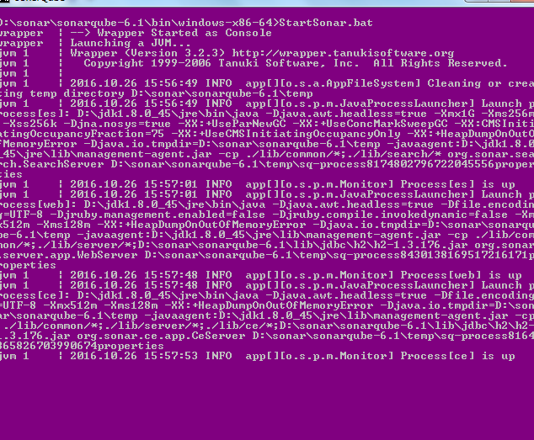

Now in browser: localhost :9081,

sonarqube installed and configured successfully!!!

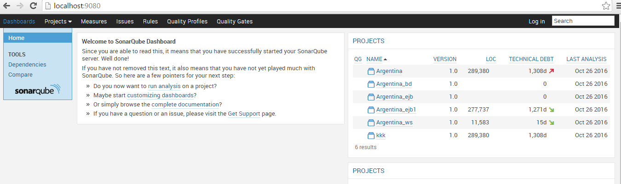

**Installing & Configuring SONARSCANNER**

1. Download SONARSCANNER (sonar-scanner-2.5.zip )
2. Unzip the zip file (sonar- scanner -2.5.zip) to a folder of your choice
3. Update the global settings (database connection, server URL) by editing the file (<sonar_scanner_HOME>\ sonar-scanner-2.5\conf\ sonar-runner.properties )

|  |
| --- |
| #Configure here general information about the environment, such as SonarQube DB details for example  #No information about specific project should appear here  #----- Default SonarQube server  #sonar.host.url=http://localhost:9000  sonar.host.url=http://localhost:9081  #----- Default source code encoding  #sonar.sourceEncoding=UTF-8  #----- Global database settings (not used for SonarQube 5.2+)  #sonar.jdbc.username=sonar  #sonar.jdbc.password=sonar  #----- PostgreSQL  #sonar.jdbc.url=jdbc:postgresql://localhost/sonar  #----- MySQL  #sonar.jdbc.url=jdbc:mysql://localhost:3306/sonar?useUnicode=true&amp;characterEncoding=utf8  #----- Oracle  #sonar.jdbc.url=jdbc:oracle:thin:@localhost/XE  #----- Microsoft SQLServer  #sonar.jdbc.url=jdbc:jtds:sqlserver://localhost/sonar;SelectMethod=Cursor |

1. Edit the sonar-runner.properties file in the conf folder

# -- Project specific configuration ------------

#---------jenkins----------------------------

sonar.projectKey=Jenkins

sonar.sources=C:\\sample.git\\src

sonar.projectName=Jenkins

sonar.projectVersion=1.0

sonar. projectkey🡪give the Key for the project to show in sonarqube dashboard.

sonar. sources🡪path where the project for which you want to analysis the code (till src folder).

sonar. projectName🡪give the name for the project to show in sonarqube dashboard.

sonar.projectVersion=1.0

NOTE: change add the Highlighted data to the config file

1. Create a new SONAR_RUNNER_HOME environment variable

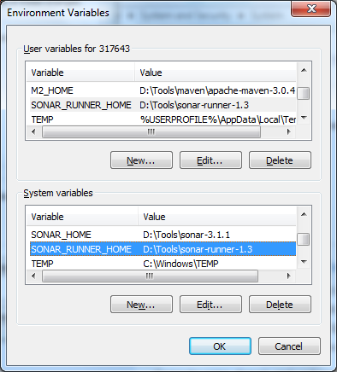

6. In the command prompt navigate to source folder



7. From there we have to navigate to <sonar_scanner_home>/bin/sonar_runner.bat and run the command



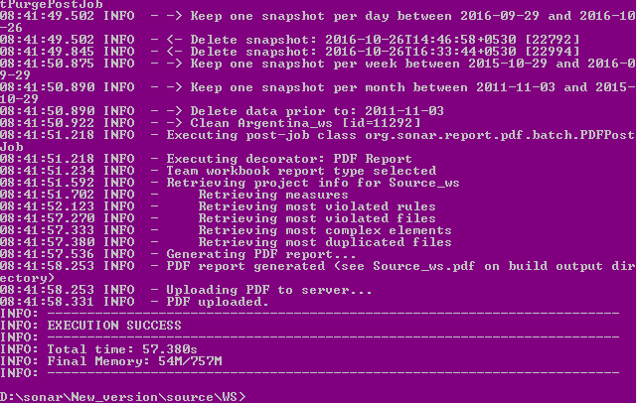

Sonarscanner installed and configured successfully!!!

